

Deep Learning-Based Automated Detection of Eye Diseases
Using CNN-BiLSTM Networks

Presented by:
Ms. Swati Khandekar

Guide Professor:
Prof. D. N. Aswar

Padmabhooshan Vasantdada Patil Institute of Technology, Bavdhan, Pune

Certificate

This is to certify that the seminar report is entitled

“Deep Learning-Based Automated Detection of Eye Diseases Using CNN-BiLSTM Networks”
Submitted by Ms. Swati Khandekar is a Bonafide work carried out under my supervision and is approved for the partial fulfillment of the requirements for the award of the degree.


Prof. D. N. Aswar Guide
Dr. S. S. Jadhav
H.O.D. (C.S.E)
Dr. R. S. Pawar Principal


Acknowledgement

I express my sincere gratitude to my guide, Prof. D. N. Aswar, for his competent guidance and timely inspiration throughout this project. His suggestions and constructive criticism kept me focused on the objective.
I would also like to thank Dr. S. S. Jadhav (Head of Department) and Dr. R. S. Pawar (Principal) for providing the infrastructure and support at PVPIT, Bavdhan.
Finally, I am thankful to the teaching and non-teaching staff of the Computer department for their unﬂinching cooperation during this work.

Ms. Swati Khandekar


Abstract

Early detection of retinal diseases like Diabetic Retinopathy, Glaucoma, and Cataract is essential to prevent permanent vision loss. This study presents a hybrid CNN-BiLSTM model for automated multi-label classification of eye diseases.
While CNNs effectively extract spatial features (textures, lesions), BiLSTM networks capture sequential dependencies across retinal regions. The model is validated on the ODIR-5K dataset, achieving a high accuracy of 92.3% and an AUC of 0.94. This research demonstrates that the combination of spatial and contextual modeling outperforms traditional CNN-only approaches, making it highly suitable for clinical decision support systems.


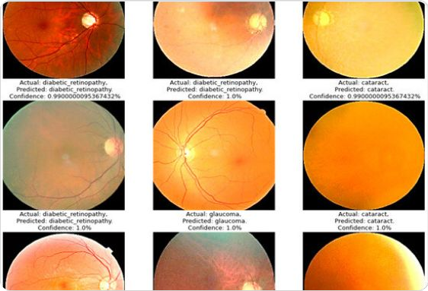
Introduction

The Global He6lth Issue
Vision impairment affects millions worldwide. Manual diagnosis is subjective and time-consuming. Critical diseases: DR, Glaucoma, Cataract, AMD.

The Proposed Solution
Automating detection using a hybrid CNN + BiLSTM approach to capture both local spatial maps and global sequential dependencies.

Motivation & Relevance








E6Tly Intervention
Timely detection can prevent 80% preventable blindness. AI provides a rapid screening tool for at-risk populations.

Medic6l Precision
Reduces dependency on specialist availability and eliminates human errors or subjectivity in manual scan interpretations.

Systemic Scalability
A trained model can process thousands of images per hour, enabling mass screening programs in rural or underserved areas.


Literatuae Review

Study | Technique | Key Finding
Fu et al. | CNN | High Diabetic Retinopathy detection accuracy.
Wang et al. | CNN-LSTM | Improved classification via spatial + temporal fusion.
Singh et al. | Transfer Learning | Boosted performance with smaller medical datasets.
Xu et al. | Ensemble Learning | Increased robustness through model voting.
Zhang et al. | Attention CNN | Focusing on critical regions improved precision.


Problem Statement

Spatial Limitations: CNNs excel at local features (lesions) but lack global contextual dependencies across retinal regions.
Sequential Dependencies: Retinal diseases often have correlated features spread across the image that require sequential modeling.
Multi-label Complexity: Real-world datasets like ODIR-5K involve comorbid conditions (multiple diseases in one eye).
Insufficiency of Simple Models: Single-label architectures fail to recognize overlapping pathologies in clinical settings.

Project Objectives


AI-Based Detection: Create an automated system for multiple eye diseases (DR, Glaucoma, Cataract, AMD).
Hybrid Design: Combine CNN (spatial) and BiLSTM (sequential) for enhanced feature representation.
Preprocessing: Standardize images using resizing, normalization, and data augmentation.
Rigorous Evaluation: Measure Accuracy, F1-score, and AUC-ROC.
Comparative Analysis: Benchmarking against traditional CNN-only baselines.
Data Optimization: Handling class imbalance and high-resolution retinal images.

Methodology: Workﬂow






Collection
Utilizing ODIR-5K dataset with fundus images and multi-disease labels.

Preprocessing
Resize to 224x224, Pixel Normalization [0,1], and Random Rotation/Flipping.

Modeling
Feature extraction via CNN followed by sequential processing via BiLSTM.

Assessment
Validation using Accuracy, Recall, and Confusion Matrix analysis.


CNN-BiLSTM Architecture

CNN (Extractor): Captures high-level spatial feature maps (bloods vessels, optic disc).
Flatten Layer: Converts 2D maps into sequential vectors.
BiLSTM (Recurrent): Captures forward and backward dependencies across the retina.
Sigmoid Activation: Enabling multi-label output for comorbid disease detection.



Algorithm & Logic

Spatial Feature Maps Extraction

Bidirectional State Concatenation

Final Prediction with Sigmoid

Optimized using Binary Cross-Entropy Loss and the Adam Optimizer.

Experimental Results: AUC-ROC




Metric Interpretation
AUC = 0.94: The model has an excellent ability to differentiate between various disease classes.
The steep rise in the curve indicates a high True Positive Rate
while maintaining a low False Positive Rate.
Significant improvement over baseline random chance (AUC = 0.5).

AUC-ROC Curve

AUC = 0.94


Confusion Matrix Analysis

The confusion matrix confirms a 92.3% accuracy across eight classes. Diagonal elements represent correct classifications.

Actual \ Pred | Normal |  | DR |  | Glaucoma |  | Cataract
Normal | 421 |  | 12 |  | 9 |  | 5
DR  Glaucoma Cataract | 14 |  | 236 |  | 7 |  | 5
 | 8 |  | 5 |  | 198 |  | 4
 | 6 |  | 4 |  | 5 |  | 175

Small overlap errors identified between Cataract vs AMD and Hypertension vs Others due to visual feature similarities.


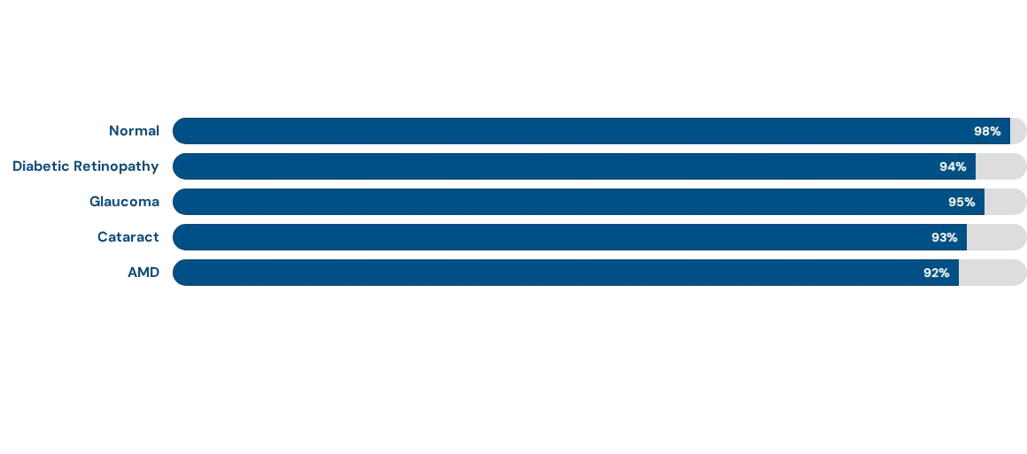
Performance Metrics by Class

Highest reliability achieved for Normal and Glaucoma classes.

Overall Performance Results

92.3%
Accuracy

91.1%
Precision

90.7%
Recall

91.0%
F1-Score







The F1-score of 91% indicates an excellent balance between Precision and Recall, ensuring robust detection in clinical environments.


Key Contribution’s

Hybrid Architecture: First-time application of BiLSTM on spatial maps for eye diseases.
Benchmarking Success: Systematically outperforms baseline CNN-only models.
Multi-label Support: Effectively identifies comorbid conditions in patients.
Practical Implementation: High accuracy (92.3%) makes it suitable for real-world diagnostic applications.
Preprocessing Pipeline: Optimized workﬂow for large medical imaging datasets like ODIR-5K.


Limitations & Future Work

Current Limitations Future Directions

Class imbalance in the ODIR-5K dataset affects some minority categories.
Variations in scan quality across different camera models.
Integrate Attention Mechanisms (Transformers) to focus on micro-lesions.
Implement Explainable AI (Grad-CAM) for diagnostic transparency.
Incorporate diverse datasets to improve global generalizability.


Conclusion

The CNN-BiLSTM model effectively detects multiple eye diseases from retinal fundus images with 92.3% accuracy.
By leveraging both spatial features via CNN and sequential dependencies via BiLSTM, the hybrid architecture provides a superior classification framework compared to traditional methods.
High metrics across Precision, Recall, and AUC confirm the model's reliability, making it a powerful candidate for clinical decision support systems to prevent irreversible vision loss.


References

Fu et al. (2020) - Deep learning for Diabetic Retinopathy detection, Journal of Medical Imaging. Wang et al. (2020) - CNN-LSTM Hybrid for Eye Disease Classification, IJCV.
Singh et al. (2020) - Improving Performance with Transfer Learning, IEEE Trans Med Imaging. Xu et al. (2020) - Ensemble Learning for Retinal Disease Diagnosis, CMIG.
Zhang et al. (2021) - Attention CNN for Accurate Detection of Eye Diseases, JBO.
Li et al. (2020) - ODIR-5K: A Large-Scale Fundus Image Dataset, Journal of Digital Imaging.



Thank You!
Any Questions?

Ms. Swati Khandekar
Computer Department, PVPIT Bavdhan, Pune Savitribai Phule Pune University

